
Assessment Cover Sheet
Unit Code and Title | ICT930 Advanced Web Application Development
Assessment Name and Number | Assessment 3 – Full-Stack Web App Development
Teaching Period / Year | Semester 2, 2026
Lecturer / Unit Coordinator | Dr. Layla Boroon
Student Full Name / ID | Group – see below
Submission Date | 05/10/2026
Submission Type | ☐ Individual ☑ Group

Team Members
Student Name | Student ID | Contribution | Responsibilities
Prasana Lal Shrestha | CIHE21603 | 34% | Project Lead & Documentation Compilation
Anjal Khadka | CIHE260230 | 33% | Database Design & Connection
Rajib Adhikari | CIHE23599 | 33% | Report and Presentation

Declaration
By submitting this assessment, I/we confirm that this work is my/our own and complies with the CIHE Academic Integrity Policy and the QA70 Use of GenAI in Teaching, Learning, Assessment and Research Policy. Any use of AI or other tools has followed the assessment instructions and guidance provided in the CIHE Student Guide on the Use of AI and has been fully acknowledged in the AI/Tool Use Declaration Table below. I/we understand that inappropriate or unacknowledged use of AI, or submission of work that is not my/our own, may constitute academic misconduct. I/we also confirm that this assessment has not been previously submitted unless approved, and I/we consent to its use for standard academic integrity, quality assurance, and AI governance review processes.
Student(s) Signature: ____________________________ Date: ______________
GenAI Tool | Description
Claude (Anthropic) | [Confirm or edit] Used to help diagnose deployment errors (Render 500/404 responses), review and suggest fixes to the React and Express code, and restructure and edit this report and the presentation slides. All suggestions were reviewed, tested and integrated by the team.

Crown Institute of Higher Education
ICT930 Advanced Web Application Development
Assessment 3 – Case Study Report
Wellness Tracker: a full-stack wellness web application
Prasana Lal Shrestha · Anjal Khadka · Rajib Adhikari
Live app: wellness-tracker-two-lime.vercel.app
Source code: github.com/ZsCypher21/wellness-tracker

1. Problem Definition
1.1 Industry context. Consumer digital health is a growing industry in which people use apps to manage everyday behaviours such as exercise, sleep, hydration and stress. The need is real: only 22.4% of Australian adults aged 18–64 met the national physical activity guidelines in 2022 (Australian Bureau of Statistics [ABS], 2023). Self-monitoring tools are one of the most practical ways to support these behaviours, but most products focus on a single habit.
1.2 Operational problem. People who track several habits end up with records spread across separate apps, notebooks and calendars, in inconsistent formats. History is hard to find and compare, there is no single view of progress against personal goals, and health appointments are often tracked somewhere else entirely. The Wellness Tracker solves this by providing one secure place to record, review, edit and delete five types of wellness data, with a dashboard and history that show change over time.
1.3 Target users and stakeholders. Primary users are adults who want a simple daily routine for logging activity, sleep, water, meditation and appointments; they need fast data entry, clear feedback and confidence that their data is private. Secondary stakeholders are health and fitness professionals who could review a client’s logged history, the organisation operating the service (which needs secure, low-cost hosting), and the development team, who need a maintainable, modular codebase that can be extended.

2. Requirements Analysis
ID | Functional requirement
FR1 | Users can register, log in and log out; each user can only access their own data.
FR2 | Create, read, update and delete entries for activities, sleep, hydration, meditation and appointments.
FR3 | Dashboard showing weekly totals, a 7-day overview chart and progress against weekly goals.
FR4 | History pages for every module; appointments split into upcoming and past.
FR5 | Profile page to edit name, bio and weekly goals; Progress page with summary and recommendations.
FR6 | Frontend and backend communicate only through a RESTful JSON API.

ID | Category | Non-functional requirement
NFR1 | Security | Passwords hashed with bcrypt; protected routes require a valid JWT; secrets stored as environment variables, not in source control; HTTPS in production.
NFR2 | Performance | Pages and API responses should complete within about 2 seconds once the server is running; list queries use indexes so they stay fast as data grows.
NFR3 | Usability | Consistent layout and navigation; forms validate input and show clear error messages; layout adapts to tablet and mobile widths.
NFR4 | Reliability | Invalid input is rejected with a 400 response rather than crashing; the database schema is checked and repaired automatically on start-up.
NFR5 | Accessibility | Form labels linked to inputs, named icon buttons, announced error/loading messages and good colour contrast.
2.3 Constraints and assumptions. The unit requires React, Node.js/Express and PostgreSQL. The project had to be built by a three-person team within one teaching period and hosted at no cost, so free hosting tiers were used. We assume users have an internet connection and a modern browser, enter their own data honestly, and that the app records wellness behaviour rather than giving medical advice.

3. Solution Design
3.1 Full-stack architecture. The system uses a three-tier architecture (Figure 1). The React single-page application handles pages, forms and client-side routing; the Express API handles authentication, validation and business rules; PostgreSQL stores all data. Separating the tiers means each can be changed and deployed independently: the frontend is hosted on Vercel and the API and database on Render.
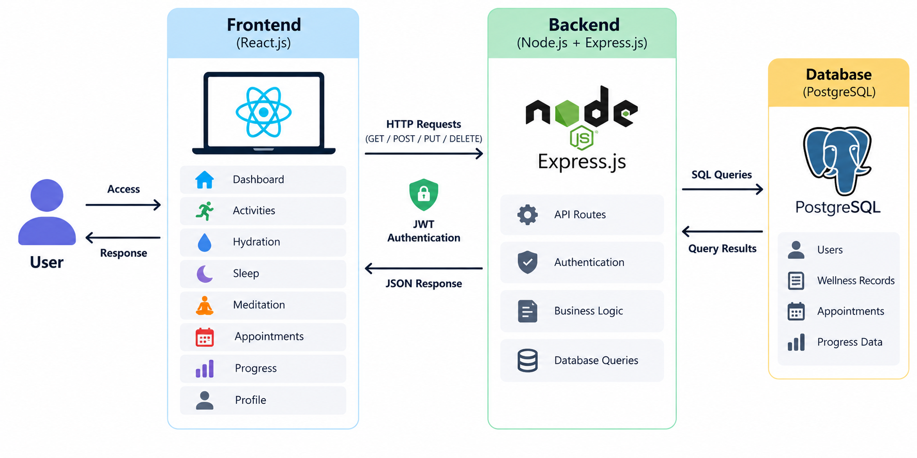
Figure 1. Three-tier architecture of the Wellness Tracker
3.2 Frontend, backend and database interaction. Every request from React goes through one service, api.js, which attaches the JWT in the Authorization header, converts any non-2xx response into an error message the user can see, and logs the user out if the token has expired (Castilho, 2023). Shared state for each module is held in a React Context provider. Express verifies the token, validates the request, runs a parameterised SQL query (preventing SQL injection) and returns JSON; React then updates the page without a reload. Each table stores a user_id foreign key, and every query filters by it, so users can never read each other’s records.
3.3 Data flow diagram. Figure 2 shows the Level 0 data flow between the user, the system and the database.
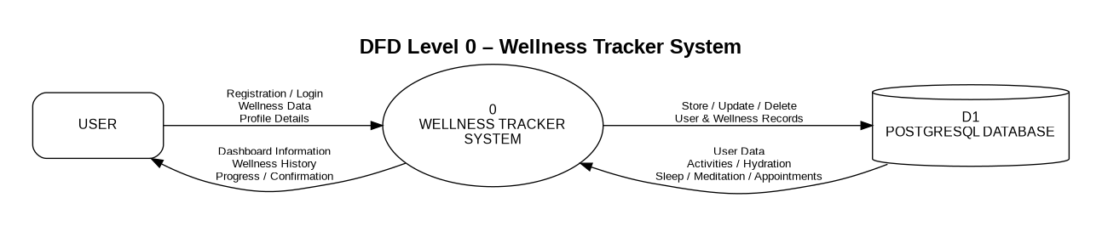
Figure 2. Level 0 data flow diagram
3.4 Database design. Seven tables: users, user_settings (bio and weekly goals, one row per user) and five log tables (activities, sleep_logs, hydration_logs, meditation_logs, appointments). Dates are stored as DATE and appointment times as TIMESTAMPTZ so they display correctly in any time zone. Composite indexes on (user_id, date) support the main “list my entries, newest first” query.
3.5 UI/UX design considerations. The interface uses one orange accent for the header and primary buttons and light card backgrounds for content, so actions stand out and pages look consistent. A slide-in sidebar gives one-click access to every module. Each module page shows the five most recent entries with Add and History buttons, and every entry has an Edit/Delete menu. Forms use the correct input types (number, date, date-time), default the date to today, and stay open with an error message if saving fails. Accessibility was addressed by linking every label to its input, giving icon-only buttons screen-reader names, and announcing errors and loading states.

4. Technology Stack Justification
Layer | Choice | Alternatives considered | Why we chose it
Frontend | React 19 + Vite, React Router 7, Recharts | Angular, Vue | Required by the unit; reusable components across five similar modules; large ecosystem (Recharts for charts); Vite gives fast builds (Chen et al., 2019).
Backend | Node.js + Express 5 | Django, Spring Boot | One language (JavaScript) across the stack; lightweight routing and middleware suit a REST API; simple JWT and bcrypt integration (Donham, 2017).
Database | PostgreSQL | MongoDB, MySQL | Data is structured and owned by a user, so relational integrity (foreign keys, types, constraints) fits better than a document store; strong read performance for filtered queries (Mamun, 2021; Urnikiene et al., 2026).
Deployment | Vercel (frontend), Render (API + PostgreSQL) | AWS, Heroku, local only | Free tiers, automatic deploys on every GitHub push, HTTPS by default and managed PostgreSQL; configuration through environment variables.

5. Implementation Overview
5.1 Key system features. Registration and login; a dashboard with summary cards, a weekly overview chart and goal progress bars; add/edit/delete for all five modules; history pages; upcoming and past appointments; a profile page with weekly goals; and a Progress page with a weekly summary, an activity breakdown by type and recommendations that compare the week’s totals with the user’s goals.
5.2 Major components developed. Frontend: seven Context providers (auth, profile and one per module), a shared api.js service, reusable UI components (Modal, HistoryItem, ProgressBar, forms and edit dialogs) and date utilities. Backend: seven Express routers, JWT middleware, a shared database-error handler that turns bad input into 400 responses, JSON 404 and error handlers, and a start-up routine that creates missing tables, repairs older table layouts and adds indexes.
5.3 Challenges encountered. Moving from localhost to the cloud surfaced real problems:
Challenge | Solution
The frontend ignored failed responses, so a 500 error looked like success. | api.js now checks every response and shows the server’s error message.
The Render database had an older activities table with different columns and was missing other tables, causing 500 errors. | A migration runs on start-up: it creates missing tables, adds missing columns and relaxes old unused columns.
Dates moved by a day and appointment times by 11 hours because of time-zone conversion. | DATE values are returned as plain text; appointment times are sent to the server in UTC.
Edit dialogs called functions that did not exist and opened with empty forms. | Rebuilt the five edit dialogs so they load the selected entry and report save errors.
Deployment configuration: API path, CORS for the Vercel domains, and a committed .env file. | Config moved to environment variables; .env removed from Git.
5.4 Team contributions. Prasana Lal Shrestha (34%) led the project, coordinated tasks and integration, managed deployment to Vercel and Render, and compiled the documentation. Anjal Khadka (33%) designed the PostgreSQL schema and connected the database to the Express backend. Rajib Adhikari (33%) wrote the report and prepared the presentation. All members contributed to frontend pages and testing, and the team met regularly because changes in one tier often affected another.

6. Testing and Evaluation
6.1 Functional testing. Each API endpoint was tested against the Express backend with a fresh PostgreSQL 16 database, including failure cases (Hasnain et al., 2021). All 11 test cases passed. ESLint reports no errors across the React and Express code.
Test case | Expected result | Result
Register; log in (email in any letter case) | 200 + JWT issued | Pass
View / update profile goals (blank goal saved as 0) | 200, values saved | Pass
Add, edit, delete an activity | 200, list updated | Pass
Add sleep, hydration and meditation entries | 200, saved for that user only | Pass
Appointments split into upcoming and past | Correct list for each | Pass
Invalid number / missing required fields | 400 Bad Request | Pass
Invalid or expired token | 401 Unauthorized | Pass
Unknown route / malformed JSON | 404 / 400 JSON error | Pass
Start-up repair of an old-layout database | Columns added, insert succeeds | Pass
6.2 Usability considerations. We checked navigation flow, form clarity and error messages manually on desktop and narrow screens. Improvements made as a result include default dates, number-only inputs, a confirmation before deleting, and readable date formats (e.g. “5 Oct 2026” instead of raw timestamps).
6.3 Limitations. There is no admin role, analytics are weekly only, all data is entered manually, and the app needs a network connection. On the free hosting tier the API sleeps when idle, so the first request can take 30–60 seconds. Testing was done by the team only; a study with real users would reveal further usability and performance issues.

7. Future Enhancements
7.1 Scalability. Paginate history pages, move to always-on hosting to remove cold starts, add caching for dashboard totals, and split modules into separate services if the user base grows.
7.2 Security. Rate limiting on login, a stronger password policy, two-factor authentication, refresh tokens stored in httpOnly cookies instead of localStorage, and audit logging (Janicke et al., 2023).
7.3 Additional features. Monthly and long-term trend charts, reminders for hydration, sleep, meditation and appointments, data export, and integration with wearables to reduce manual entry.

References
Australian Bureau of Statistics. (2023, December 15). Physical activity, 2022. https://www.abs.gov.au/statistics/health/health-conditions-and-risks/physical-activity/latest-release
Castilho, R. (2023). Fetch API — Understanding JavaScript API requests and responses in the data fetching lifecycle. DEV Community. https://dev.to/rodcast/fetch-api-understanding-javascript-api-requests-and-responses-in-the-data-fetching-lifecycle-407k
Chen, S., Thaduri, U. R., & Ballamudi, V. K. R. (2019). Front-end development in React: An overview. Engineering International, 7(2), 117–126. https://doi.org/10.18034/EI.V7I2.662
Donham, P. (2017). Using JWTs for authentication in RESTful applications. https://sites.bu.edu/perryd/2017/12/28/using-jwts-for-authentication-in-restful-applications/
Hasnain, M., Pasha, M. F., Ghani, I., & Jeong, S. R. (2021). Functional requirement-based test case prioritization in regression testing: A systematic literature review. SN Computer Science, 2(6), 421. https://doi.org/10.1007/S42979-021-00821-3
Janicke, H., Amine Ferrag, M., Aparicio-Navarro, F. J., Bucko, A., Vishi, K., Krasniqi, B., & Rexha, B. (2023). Enhancing JWT authentication and authorization in web applications based on user behavior history. Computers, 12(4), 78. https://doi.org/10.3390/COMPUTERS12040078
Mamun, A. M. Al. (2021). What is PostgreSQL? Open-source database system. Server Watch. https://www.serverwatch.com/guides/what-is-postgresql/
Urnikiene, J., Steponaviciene, V., & Atanasov, S. (2026). Comparative read performance analysis of PostgreSQL and MongoDB in e-commerce: An empirical study of filtering and analytical queries. Big Data and Cognitive Computing, 10(2), 66. https://doi.org/10.3390/BDCC10020066

Appendix A – Screenshots and Access
Access. Live app: https://wellness-tracker-two-lime.vercel.app · GitHub: https://github.com/ZsCypher21/wellness-tracker (see README.md for setup) · Test account: zsc21@test.com / Nepal123456
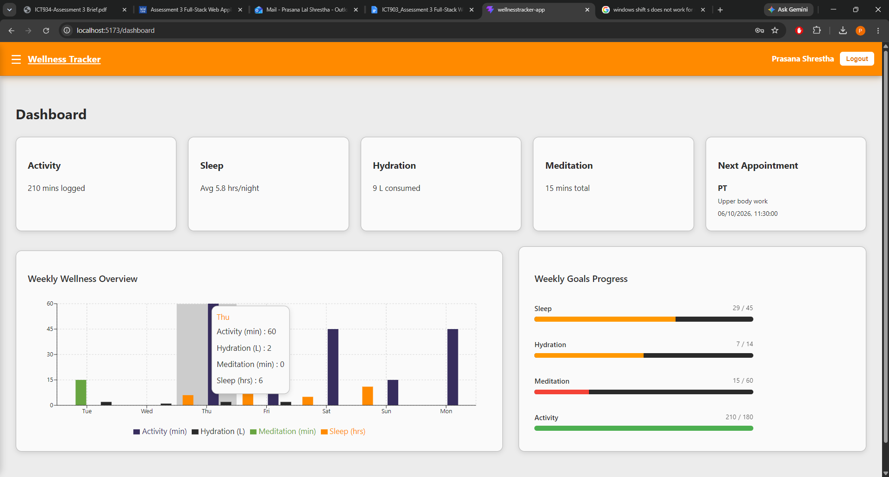
A1. Dashboard with weekly overview chart (hover for daily detail) and weekly goals progress
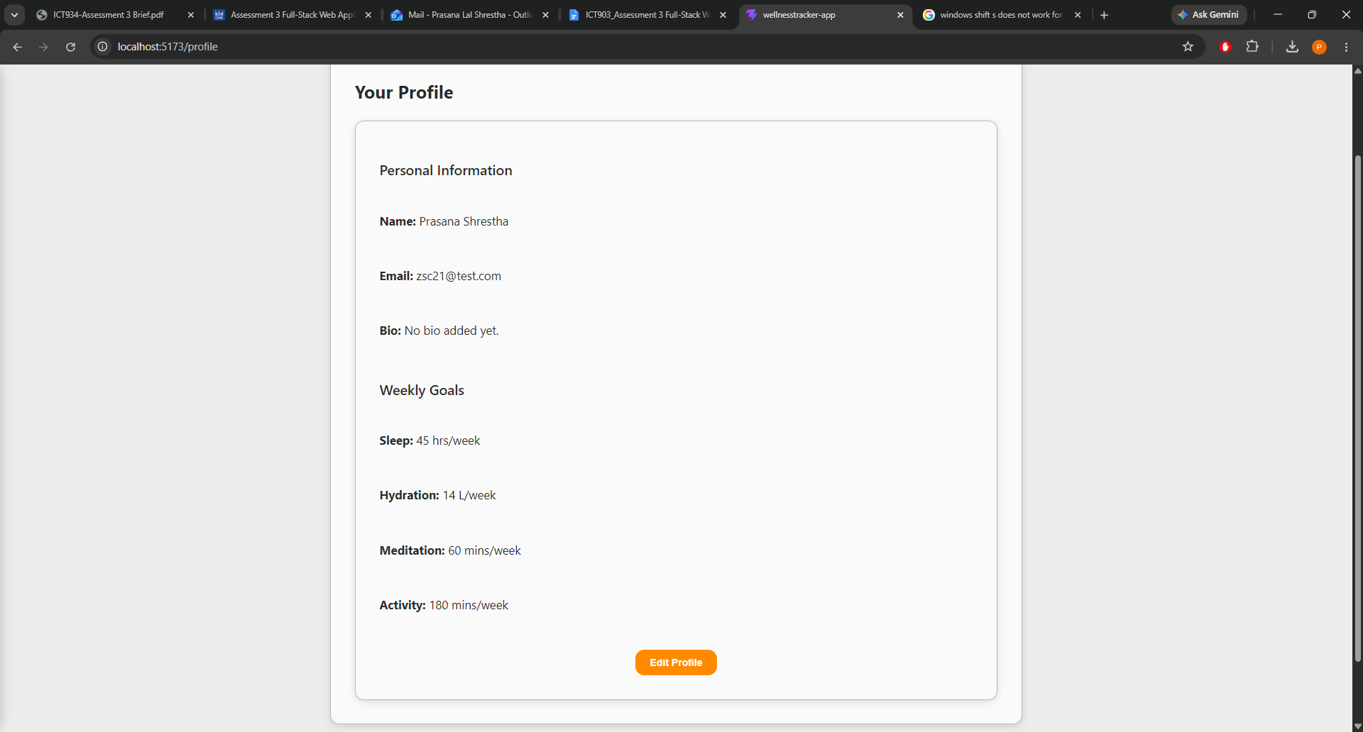
A2. Profile page (opened from the user name in the navbar)
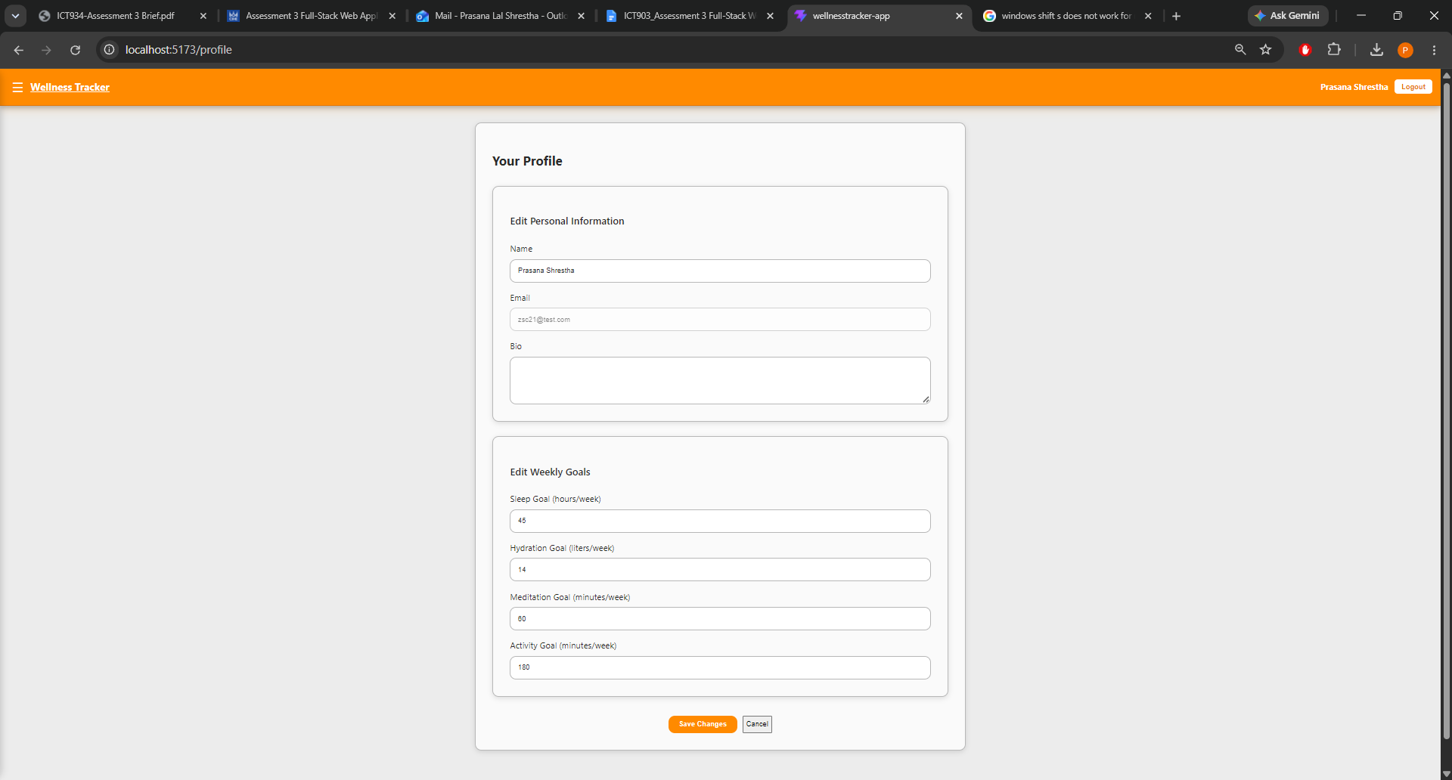
A3. Editing the profile and weekly goals
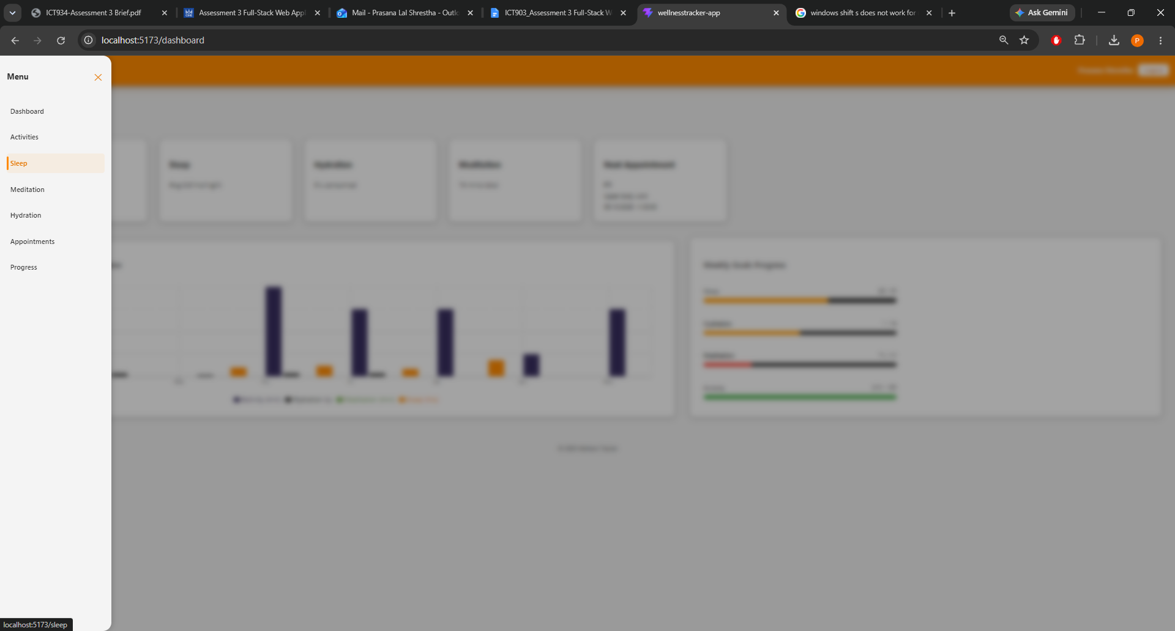
A4. Sidebar navigation
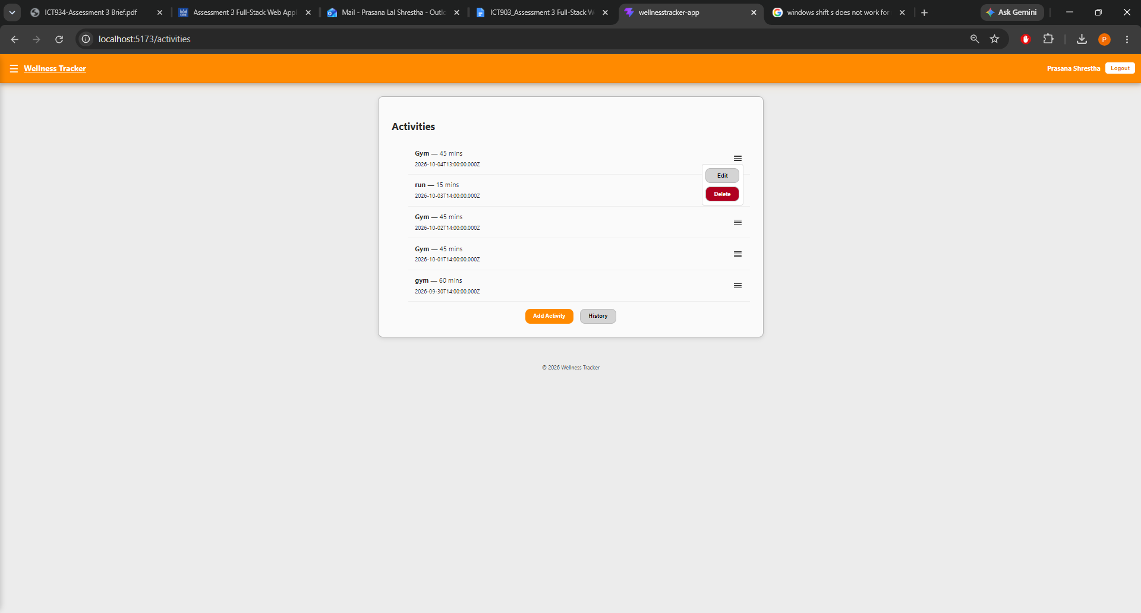
A5. Activities page with the Edit / Delete menu
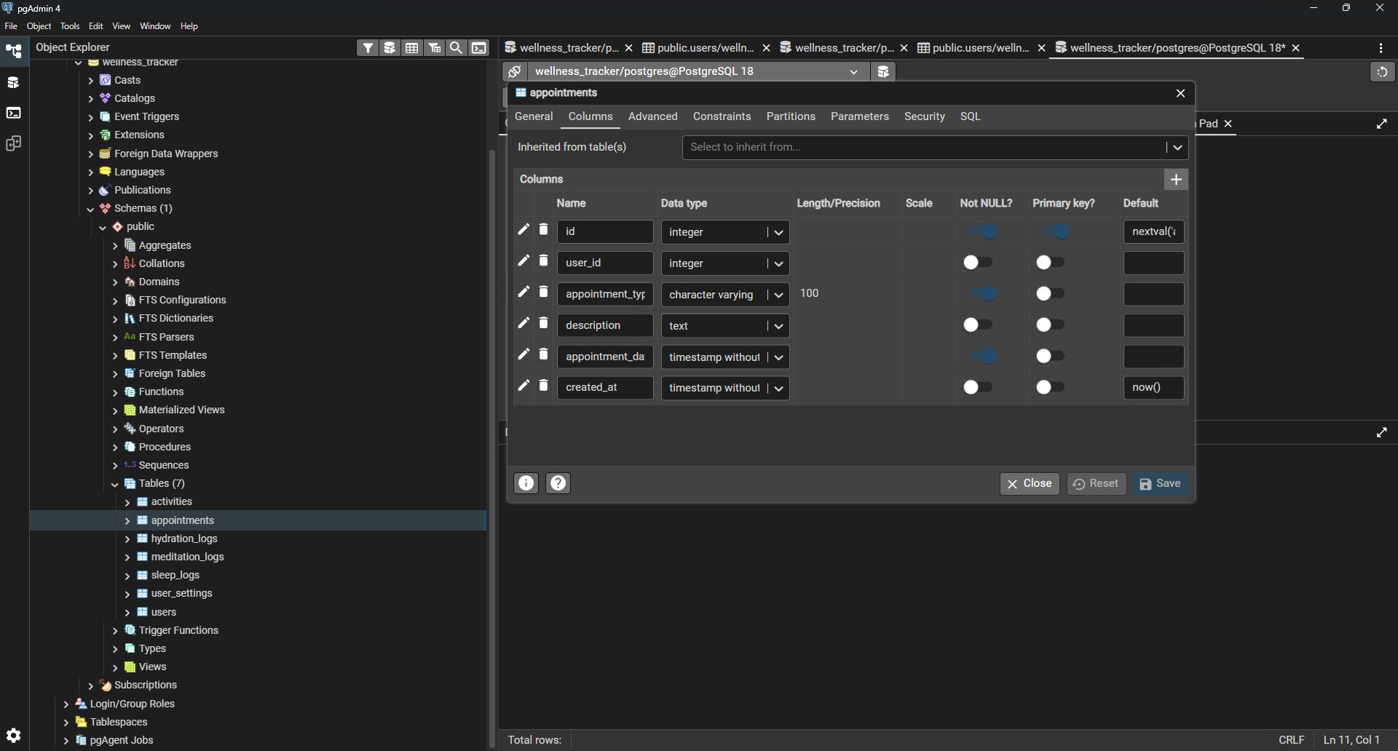
A6. appointments table structure in pgAdmin 4
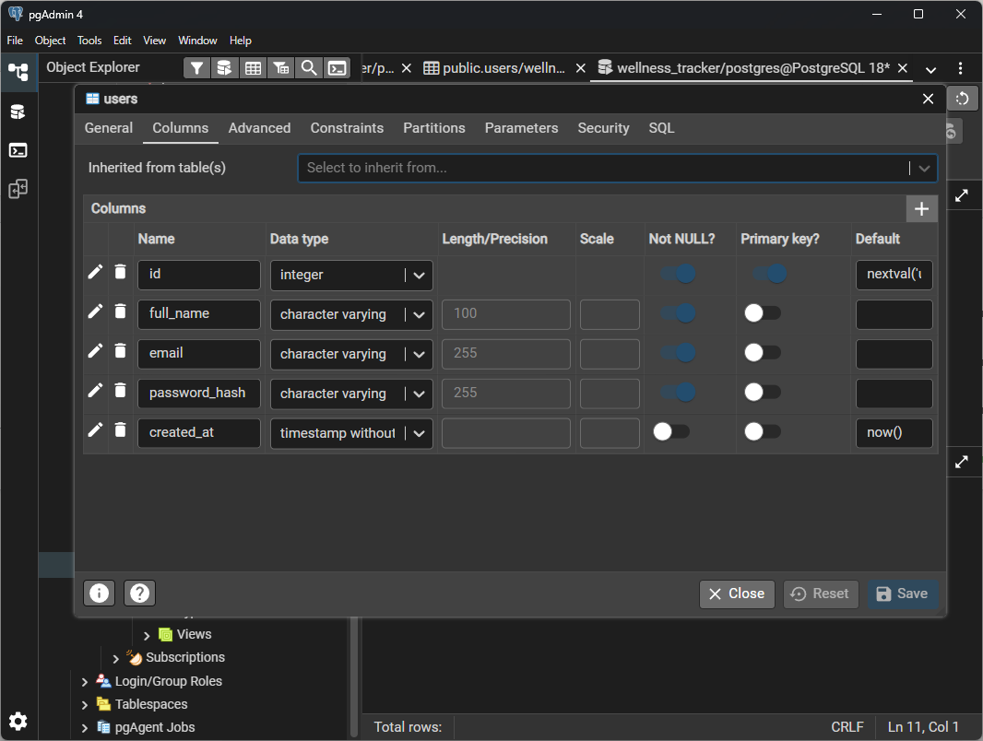
A7. users table structure in pgAdmin 4

